

**Report of Web application**

**Students information:**

U1610112 Yakubov Khurshid - Team Leader

U1710218 Bakoev Nodirjon

U1710096 Sadullaev Bakhromjon

U1710061 Muradov Farkhod

U1710098 Jumaev Saidjon

U1710186 Tojiboev Khusanbek

**Team Name: Thunderbolt**

**Team Motto: Creative, flexible and affordable website design**



**GitHub Link:** [**https://github.com/iuthub/design-project-thunderbolt**](https://github.com/iuthub/design-project-thunderbolt)

**Website Link:**

Table of contents

___About Company___

___Main functions of the website___

Website in details

**___**Main page description_______

___Header description__________

___Body description___________

___Footer description__________

___Admin page description_____

___Summary of the project______

About company

Our company is oriented for developing websites for business or private companies. Today, many web developers are making high quality websites and people who own for private business wants to make a website in order to inform their clients and business partners. In Uzbekistan, many owners of company encountering with problems in the field of advertisement and own for their private web site. So our main aim is to tackle the difficulties between web developers and clients for owing to web site.

Main functions of the website

Here visitors can easily find many types of web sites as an examples of their business. Our admins provide with latest well-designed web sites on the daily basis. So the visitors and our clients can easily be informed with our products. Furthermore, they can contact with us and order for a web site which they want or can organize face to face communication for further description of their web site. Our web developers sustain permanent service of websites for our clients.

Website in details

After our team members decided to make a web site business site, many features and aspects debated and discussed.

The design of our web site can allure or make detrimental effect on the development of our business. On top of that, our web site offers the web site templates and examples for business owners, so they can conclude their partnership with our web site. We tried to make user friendly interface and simple design.

Main page description

On the main page, you can see navigation, multiple blocks, subscribe option and footer.

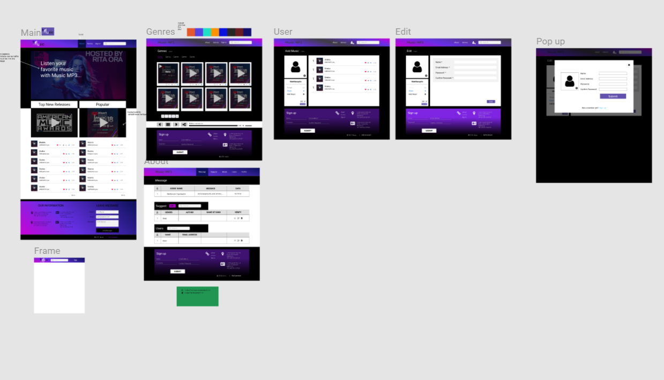Header description



In this navbar we used bootstrap and CSS styles as well as JavaScript for animation.

Navbar contain three links like Home, Feature, Portfolio and it directs each section. On the left side our company name is written.

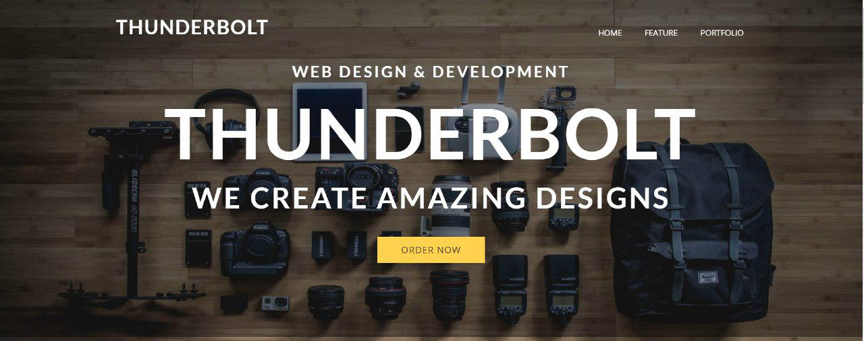

If our clients push the order now link they can buy or book the web sites which they preferred. In near future, we will provide with well-made web sites and they can order and own for their preferable sites.

Main page body part

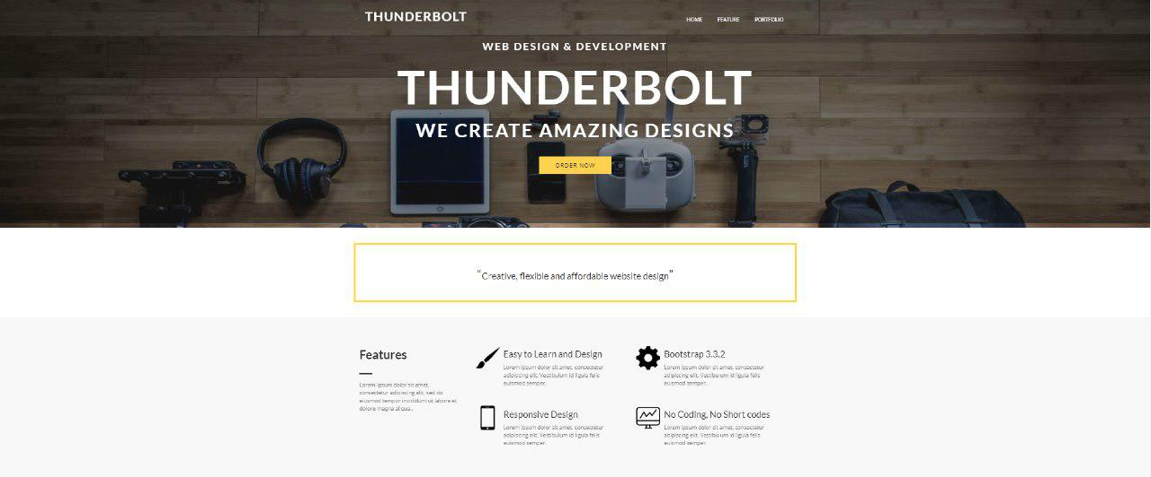

On this body part you can see some features and options for clients. They can get information about web field and can be informed details and interesting parts of web developing. It is not only for clients, but also for people who are interested on web programming. They can broaden their horizon in the field of web developing.

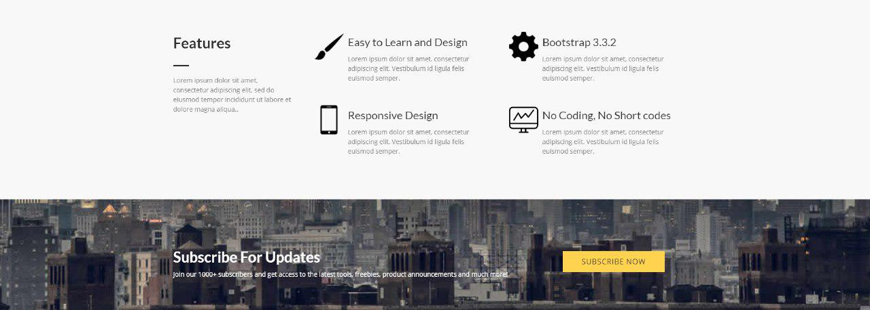

Footer description

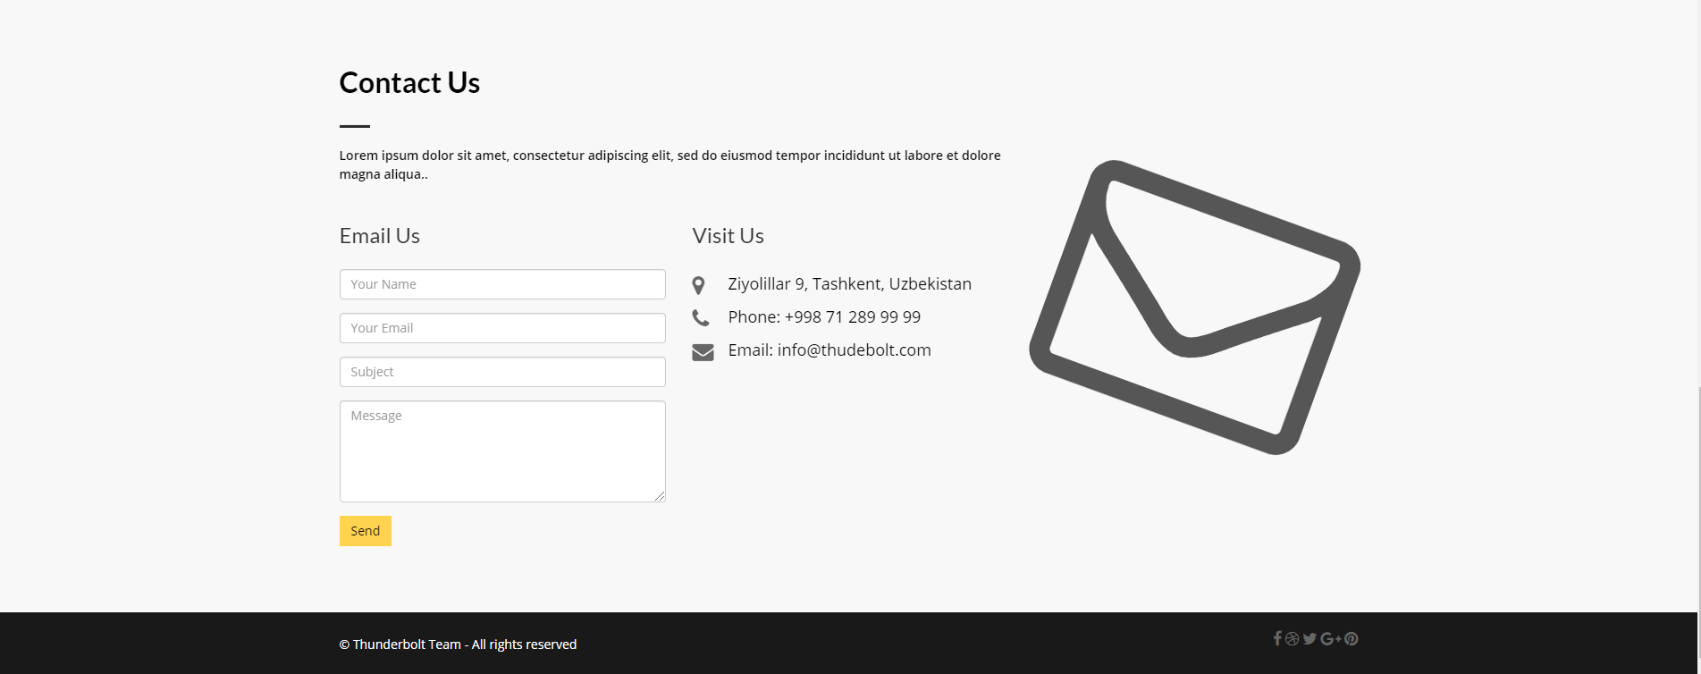

In this part, visitors of our web site can be informed with our location, mail and telephone number. On top of that, they can send their opinion and further comments to us via filling the blanks which asks them Name, Mail, Subject and their message.

Admin Page description

In Admin Panel there is header with links Menu, Features, Feedbacks, Screenshots, Menu5, Menu6

We have 5 functional. Every header has his own functional. We take attention to features

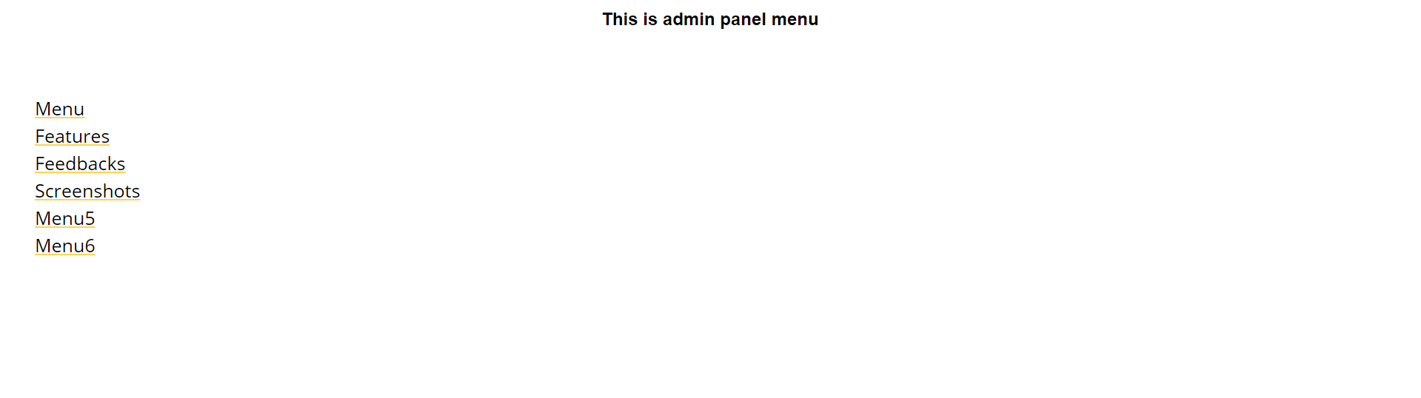

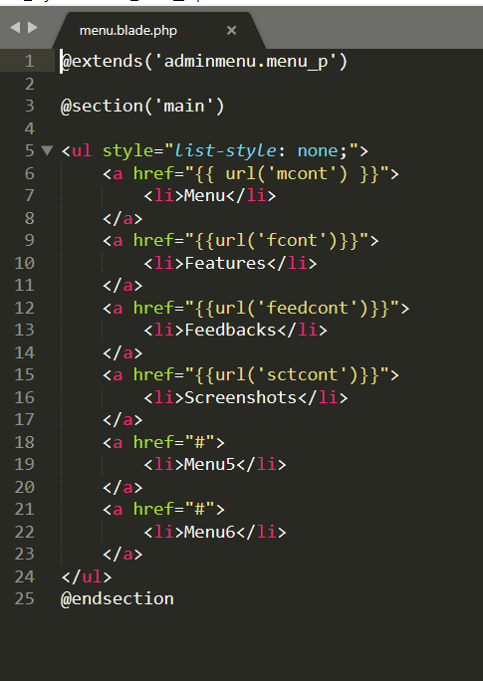

Features Table

In features table we can change main page view we can add images ,titles and descriptions. In body part we write default description

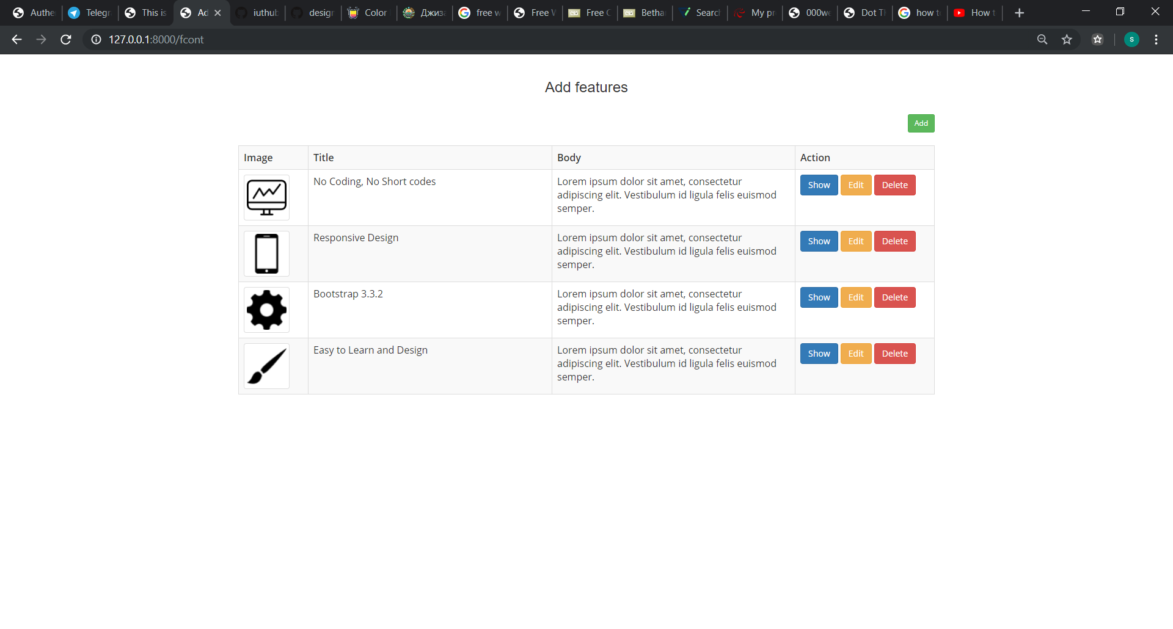

1. Features page contains data about Image Title Body Action.

Action contains 3 functions

1 Show

2 Edit

3 delete



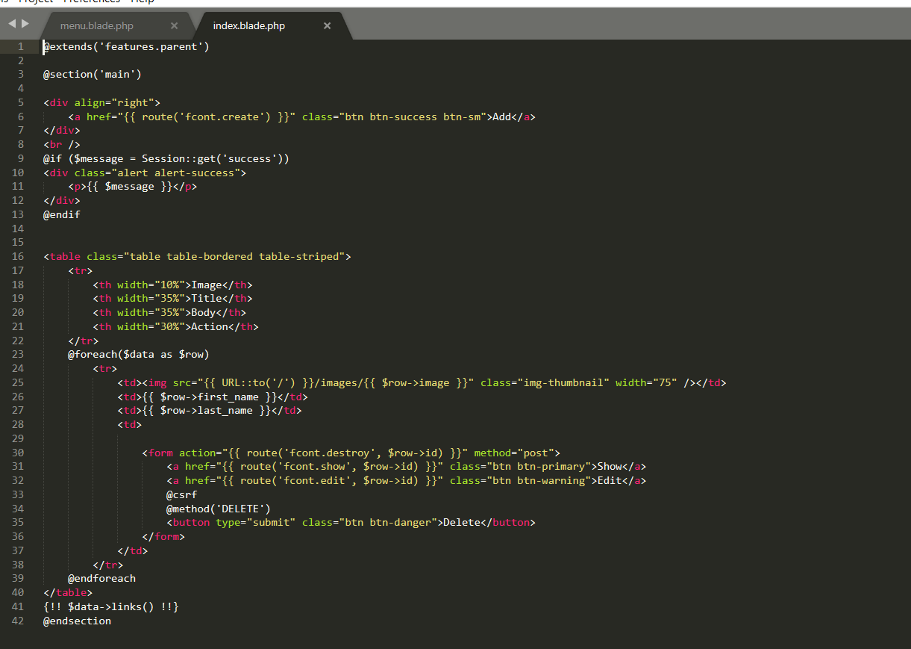

1. Show
2. 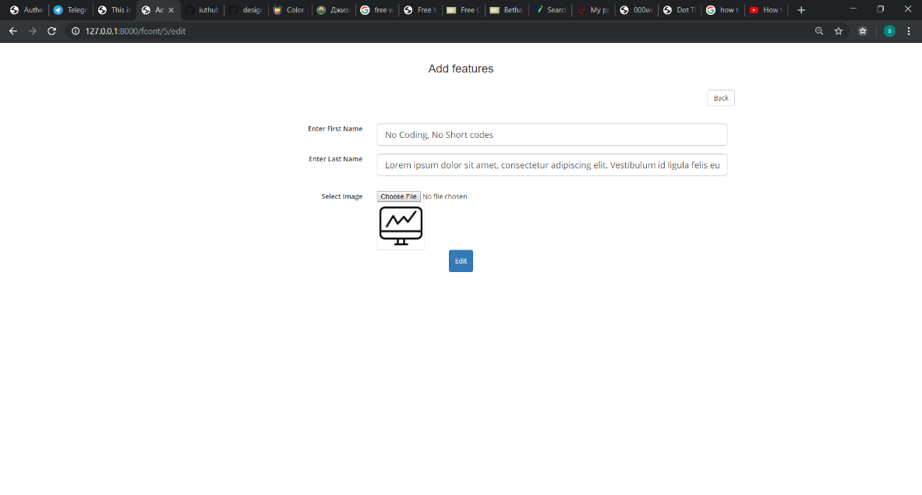
3. 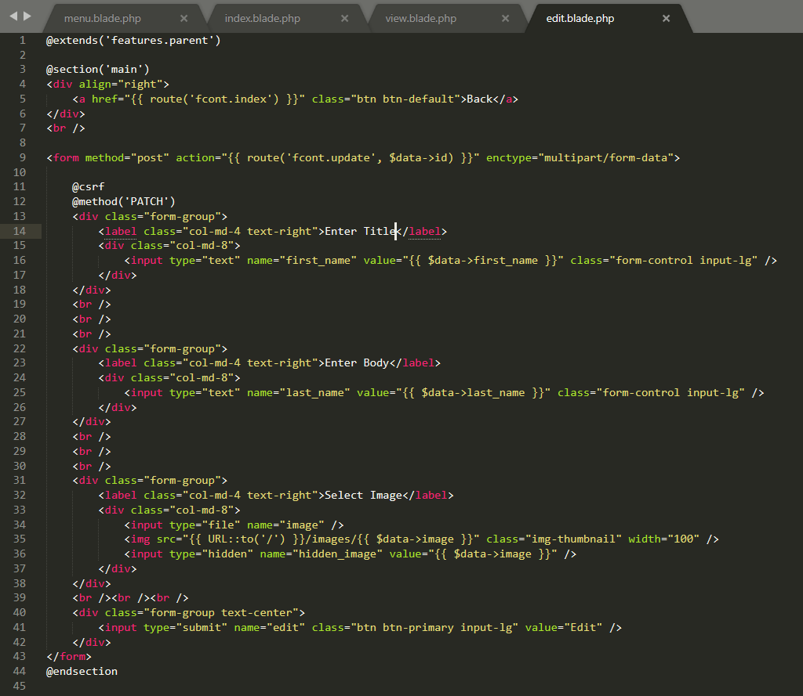

2.Edit

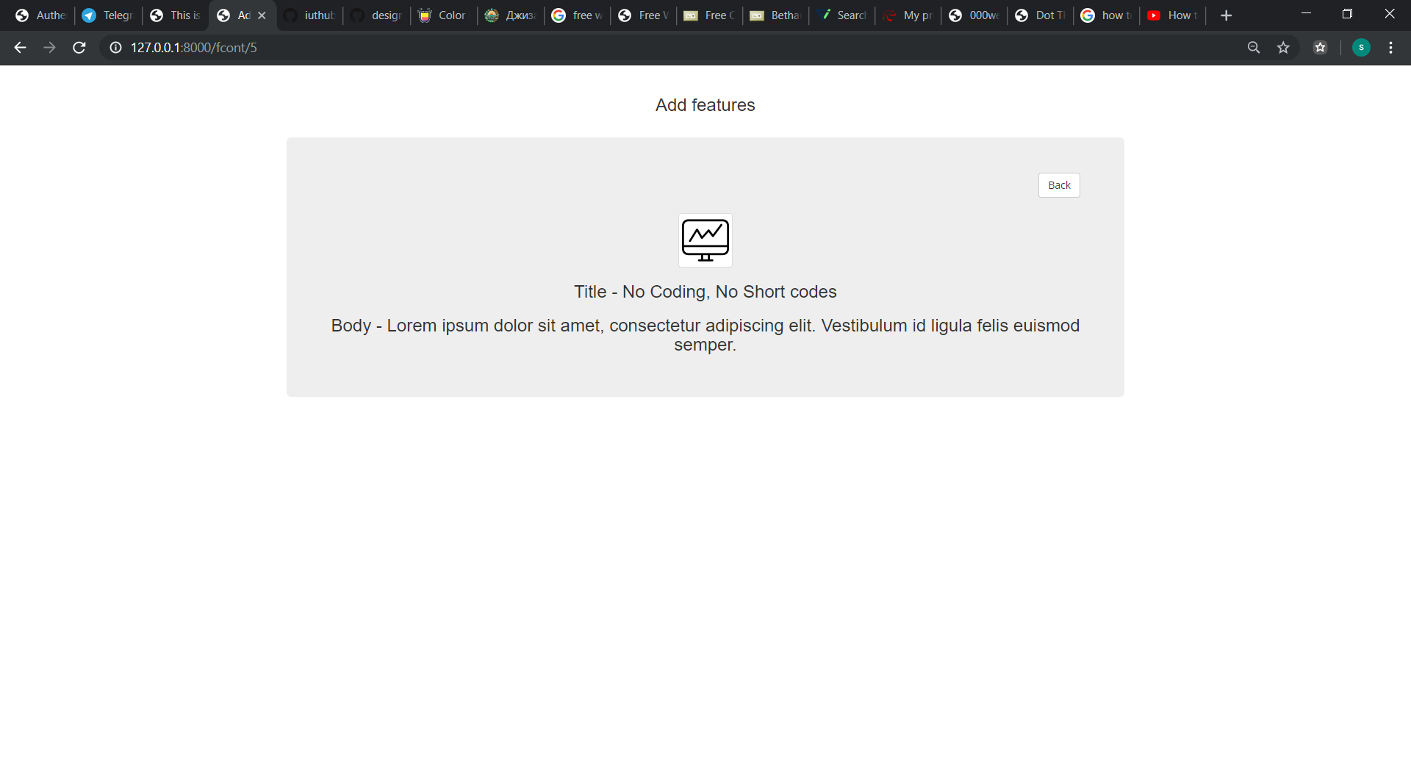

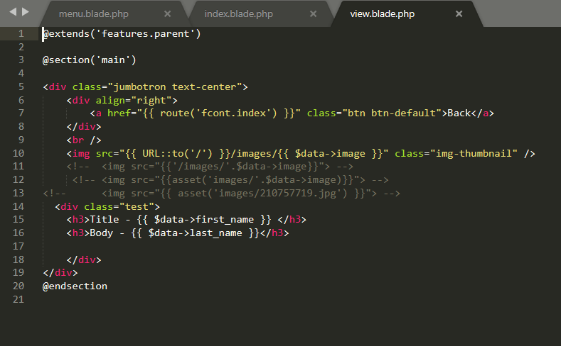

3 Delete

In delete we can delete titles, images, body, titles

Add features

After making all process you can add your image title everything what you want.